Cut norms

Def

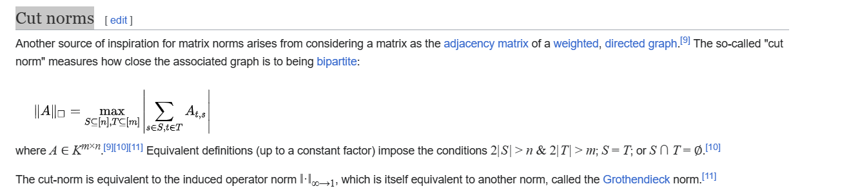

Extension

Grothendieck norm

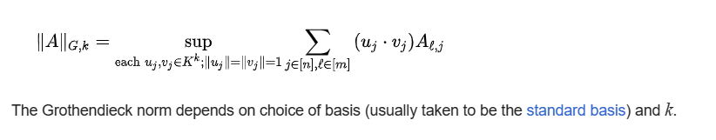

Ref

See cut norms section in Wiki,

[Matrix norm - Wikipedia](https://en.wikipedia.org/wiki/Matrix_norm)